**Service**

В тексте задания полностью отсутствует информация о работе с ViewActivity.java. То есть, если следовать только заданию, приложение не заработает.

Исходный код проекта:

<https://github.com/verkhoumov/AndroidLabs/tree/master/Service>

Скриншоты экрана:

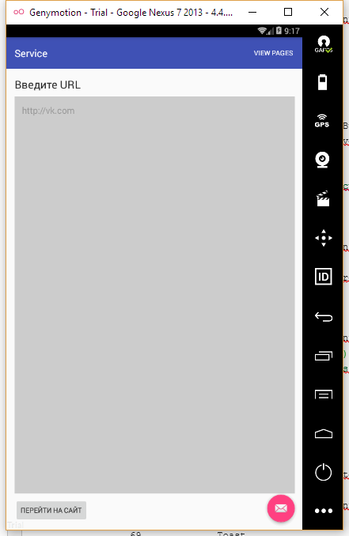

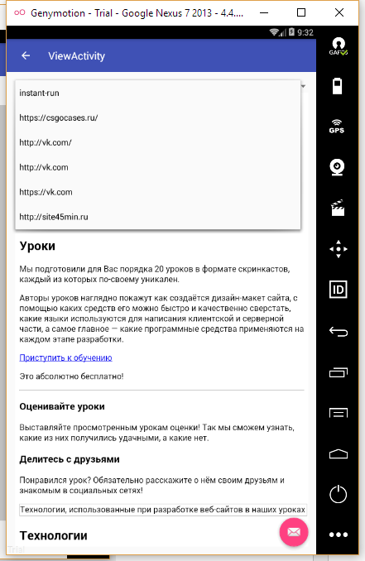

Исходный код.

MainActivity.java:

1. **package** ru.verkhoumov.service;
3. **import** android.content.Intent;
4. **import** android.os.Bundle;
5. **import** android.os.StrictMode;
6. **import** android.support.design.widget.FloatingActionButton;
7. **import** android.support.design.widget.Snackbar;
8. **import** android.support.v7.app.AppCompatActivity;
9. **import** android.support.v7.widget.Toolbar;
10. **import** android.view.View;
11. **import** android.view.Menu;
12. **import** android.view.MenuItem;
13. **import** android.widget.EditText;
15. **public** **class** MainActivity **extends** AppCompatActivity {
17. @Override
18. **protected** **void** onCreate(Bundle savedInstanceState) {
19. **super**.onCreate(savedInstanceState);
20. setContentView(R.layout.activity_main);
21. Toolbar toolbar = (Toolbar) findViewById(R.id.toolbar);
22. setSupportActionBar(toolbar);
24. StrictMode.ThreadPolicy policy = **new** StrictMode.ThreadPolicy.Builder().permitAll().build();
25. StrictMode.setThreadPolicy(policy);
27. FloatingActionButton fab = (FloatingActionButton) findViewById(R.id.fab);
28. fab.setOnClickListener(**new** View.OnClickListener() {
29. @Override
30. **public** **void** onClick(View view) {
31. Snackbar.make(view, "Replace with your own action", Snackbar.LENGTH_LONG)
32. .setAction("Action", **null**).show();
33. }
34. });
35. }
37. @Override
38. **public** **boolean** onCreateOptionsMenu(Menu menu) {
39. *// Inflate the menu; this adds items to the action bar if it is present.*
40. getMenuInflater().inflate(R.menu.menu_main, menu);
41. **return** **true**;
42. }
44. @Override
45. **public** **boolean** onOptionsItemSelected(MenuItem item) {
46. **int** id = item.getItemId();
48. **if** (id == R.id.action_view) {
49. Intent intent = **new** Intent(**this**, ViewActivity.**class**);
50. startActivity(intent);
52. **return** **true**;
53. }
55. **return** **super**.onOptionsItemSelected(item);
56. }
58. **public** **void** getWebPages(View view) {
59. *// Формируем ссылку на поле формы.*
60. EditText editText = (EditText) findViewById(R.id.formEdit);
62. *// Создаём новый сервис.*
63. Intent intent = **new** Intent(**this**, URLService.**class**);
64. intent.putExtra("link", editText.getText().toString());
65. startService(intent);
66. }
67. }

ViewActivity.java:

1. **package** ru.verkhoumov.service;
3. **import** android.graphics.Color;
4. **import** android.os.Bundle;
5. **import** android.support.design.widget.FloatingActionButton;
6. **import** android.support.design.widget.Snackbar;
7. **import** android.support.v7.app.AppCompatActivity;
8. **import** android.support.v7.widget.Toolbar;
9. **import** android.util.Log;
10. **import** android.view.View;
11. **import** android.webkit.WebView;
12. **import** android.widget.AdapterView;
13. **import** android.widget.ArrayAdapter;
14. **import** android.widget.Spinner;
16. **import** java.io.BufferedReader;
17. **import** java.io.File;
18. **import** java.io.FileNotFoundException;
19. **import** java.io.FileReader;
20. **import** java.io.IOException;
21. **import** java.util.Iterator;
23. **public** **class** ViewActivity **extends** AppCompatActivity {
24. @Override
25. **protected** **void** onCreate(Bundle savedInstanceState) {
26. **super**.onCreate(savedInstanceState);
27. setContentView(R.layout.activity_view);
29. Toolbar toolbar = (Toolbar) findViewById(R.id.toolbar);
30. setSupportActionBar(toolbar);
32. FloatingActionButton fab = (FloatingActionButton) findViewById(R.id.fab);
33. fab.setOnClickListener(**new** View.OnClickListener() {
34. @Override
35. **public** **void** onClick(View view) {
36. Snackbar.make(view, "Replace with your own action", Snackbar.LENGTH_LONG)
37. .setAction("Action", **null**).show();
38. }
39. });
40. getSupportActionBar().setDisplayHomeAsUpEnabled(**true**);
42. *// Ссылка на выпадающий список.*
43. Spinner spinner = (Spinner) findViewById(R.id.spinner);
45. *// Сохранённые файлы.*
46. File saveDir = getFilesDir();
48. **if** (saveDir.exists()) {
49. **final** String[] files = saveDir.list();
50. String[] _files = **new** String[files.length];
52. **for** (**int** i = 0; i < _files.length; i++) {
53. _files[i] = files[i].toString().replaceAll("@@", "/").replaceAll("##", ":");
54. }
56. *// Используем адаптер для построения выпадающего списка.*
57. ArrayAdapter<String> dataAdapter = **new** ArrayAdapter<String>(**this**, android.R.layout.simple_spinner_item, _files);
58. dataAdapter.setDropDownViewResource(android.R.layout.simple_spinner_dropdown_item);
59. spinner.setAdapter(dataAdapter);
61. *// При выборе пункта из списка загружаем страницу.*
62. spinner.setOnItemSelectedListener(**new** AdapterView.OnItemSelectedListener() {
63. @Override
64. **public** **void** onItemSelected(AdapterView<?> adapterView, View view, **int** position, **long** id) {
65. *// Элемент из выбранного пункта.*
66. Object itemByPosition = adapterView.getItemAtPosition(position);
68. *// Загружаем файл с соответствующим именем.*
69. File file = **new** File(getFilesDir(), files[(**int**) id]);
71. *// Используем специальное окно для загрузки веб-страницы.*
72. WebView webView = (WebView) findViewById(R.id.webview);
74. **if** (file.exists()) {
75. FileReader fileReader = **null**;
76. BufferedReader bufferedReader = **null**;
78. **try** {
79. fileReader = **new** FileReader(file);
80. bufferedReader = **new** BufferedReader(fileReader);
82. StringBuilder buffer = **new** StringBuilder();
83. String line;
85. **while** ((line = bufferedReader.readLine()) != **null**) {
86. buffer.append(line);
87. }
89. webView.loadDataWithBaseURL(**null**, buffer.toString(), "text/html", "UTF-8", **null**);
90. } **catch** (FileNotFoundException e) {
91. e.printStackTrace();
92. } **catch** (IOException e) {
93. e.printStackTrace();
94. }
95. } **else** {
96. webView.loadUrl(itemByPosition.toString());
97. }
98. }
100. @Override
101. **public** **void** onNothingSelected(AdapterView<?> adapterView) {
102. *// Required.*
103. }
104. });
105. }
106. }
107. }

URLService.java:

1. **package** ru.verkhoumov.service;
3. **import** android.app.IntentService;
4. **import** android.content.Intent;
6. **import** java.io.BufferedReader;
7. **import** java.io.File;
8. **import** java.io.InputStreamReader;
9. **import** java.io.PrintWriter;
10. **import** java.net.MalformedURLException;
11. **import** java.net.URL;
12. **import** java.util.StringTokenizer;
14. **public** **class** URLService **extends** IntentService {
15. **public** URLService() {
16. **super**("URLService");
17. }
19. @Override
20. **protected** **void** onHandleIntent(Intent intent) {
21. *// Получение адреса сайта из формы.*
22. String link = intent.getStringExtra("link");
24. **if** (link == **null**) {
25. **return**;
26. }
28. *// Разбитие строк на части.*
29. StringTokenizer tokenizer = **new** StringTokenizer(link);
31. **int** tokenCount = tokenizer.countTokens();
32. **int** index = 0;
34. String[] targets = **new** String[tokenCount];
36. **while** (tokenizer.hasMoreTokens()) {
37. targets[index++] = tokenizer.nextToken();
38. }
40. File saveDir = getFilesDir();
42. getPagesAndSave(saveDir, targets);
43. }
45. **private** **void** getPagesAndSave(File saveDir, String[] targets) {
46. **for** (String target: targets) {
47. URL url = **null**;
49. **try** {
50. url = **new** URL(target);
51. } **catch** (MalformedURLException e) {
52. e.printStackTrace();
53. }
55. String fileName = target.replaceAll("/", "@@").replaceAll(":", "##");
57. File file = **new** File(saveDir, fileName);
59. PrintWriter writer = **null**;
60. BufferedReader reader = **null**;
62. **try** {
63. String line;
65. writer = **new** PrintWriter(file);
66. reader = **new** BufferedReader(**new** InputStreamReader(url.openStream()));
68. **while** ((line = reader.readLine()) != **null**) {
69. writer.write(line);
70. }
71. } **catch** (Exception e) {
72. e.printStackTrace();
73. } **finally** {
74. **if** (writer != **null**) {
75. **try** {
76. writer.close();
77. } **catch** (Exception e) {
78. e.printStackTrace();
79. }
80. }
82. **if** (reader != **null**) {
83. **try** {
84. reader.close();
85. } **catch** (Exception e) {
86. e.printStackTrace();
87. }
88. }
89. }
90. }
91. }
92. }

content_main.xml:

1. **<?xml** version="1.0" encoding="utf-8"**?>**
2. **<RelativeLayout** xmlns:android="http://schemas.android.com/apk/res/android"
3. xmlns:app="http://schemas.android.com/apk/res-auto"
4. xmlns:tools="http://schemas.android.com/tools"
5. android:layout_width="match_parent"
6. android:layout_height="match_parent"
7. android:paddingBottom="@dimen/activity_vertical_margin"
8. android:paddingLeft="@dimen/activity_horizontal_margin"
9. android:paddingRight="@dimen/activity_horizontal_margin"
10. android:paddingTop="@dimen/activity_vertical_margin"
11. app:layout_behavior="@string/appbar_scrolling_view_behavior"
12. tools:context="ru.verkhoumov.service.MainActivity"
13. tools:showIn="@layout/activity_main"**>**
15. **<TextView**
16. android:id="@+id/formLabel"
17. android:layout_width="wrap_content"
18. android:layout_height="wrap_content"
19. android:text="@string/input_label"
20. android:textAppearance="?android:attr/textAppearanceLarge"
21. android:layout_alignParentTop="true" **/>**
23. **<Button**
24. android:id="@+id/formButton"
25. android:layout_width="wrap_content"
26. android:layout_height="wrap_content"
27. android:text="@string/input_button"
28. android:onClick="getWebPages"
29. android:layout_alignParentBottom="true" **/>**
31. **<EditText**
32. android:id="@+id/formEdit"
33. android:layout_width="match_parent"
34. android:layout_height="match_parent"
35. android:background="#cccccc"
36. android:textColor="#333333"
37. android:textColorHint="#999999"
38. android:inputType="textUri"
39. android:layout_below="@id/formLabel"
40. android:layout_above="@id/formButton"
41. android:layout_marginTop="10dp"
42. android:layout_marginBottom="10dp"
43. android:hint="@string/input_hint"
44. android:padding="15dp"
45. android:gravity="start|top" **/>**
46. **</RelativeLayout>**

content_view.xml:

1. **<?xml** version="1.0" encoding="utf-8"**?>**
2. **<LinearLayout** xmlns:android="http://schemas.android.com/apk/res/android"
3. xmlns:app="http://schemas.android.com/apk/res-auto"
4. xmlns:tools="http://schemas.android.com/tools"
5. android:id="@+id/content_view"
6. android:orientation="vertical"
7. android:layout_width="match_parent"
8. android:layout_height="match_parent"
9. android:paddingBottom="@dimen/activity_vertical_margin"
10. android:paddingLeft="@dimen/activity_horizontal_margin"
11. android:paddingRight="@dimen/activity_horizontal_margin"
12. android:paddingTop="@dimen/activity_vertical_margin"
13. app:layout_behavior="@string/appbar_scrolling_view_behavior"
14. tools:context="ru.verkhoumov.service.ViewActivity"
15. tools:showIn="@layout/activity_view"**>**
17. **<Spinner**
18. android:layout_width="match_parent"
19. android:layout_height="wrap_content"
20. android:id="@+id/spinner" **/>**
22. **<WebView**
23. android:layout_width="match_parent"
24. android:layout_height="match_parent"
25. android:id="@+id/webview" **/>**
26. **</LinearLayout>**

menu_main.xml:

1. **<menu** xmlns:android="http://schemas.android.com/apk/res/android"
2. xmlns:app="http://schemas.android.com/apk/res-auto"
3. xmlns:tools="http://schemas.android.com/tools"
4. tools:context="ru.verkhoumov.service.MainActivity"**>**
5. **<item**
6. android:id="@+id/action_view"
7. android:orderInCategory="100"
8. android:title="@string/action_view"
9. app:showAsAction="always" **/>**
10. **</menu>**

strings.xml:

1. **<resources>**
2. **<string** name="app_name"**>**Service**</string>**
3. **<string** name="action_settings"**>**Settings**</string>**
4. **<string** name="input_label"**>**Введите URL**</string>**
5. **<string** name="input_hint"**>**http://vk.com**</string>**
6. **<string** name="input_button"**>**Перейти на сайт**</string>**
7. **<string** name="action_view"**>**View pages**</string>**
8. **<string** name="title_activity_view"**>**ViewActivity**</string>**
9. **</resources>**